**LAB #06**

**NAME : SHERJEEL AHMED**

**ROLL NO :24K-0724**

**COURSE : PROGRAMMING FUNDAMENTALS**

**COURSE INSTRUCTOR: MUHAMMAD AASHIR**

1. **Write a C Program that takes an user input array and prints the sum of its elements.**

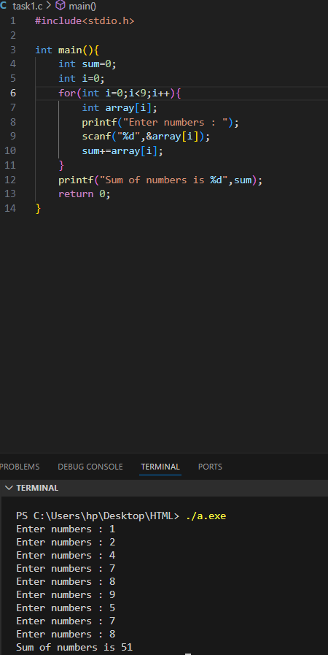

1. **Write a program in C to read n number of values in an array and display it in reverse order**

1. **Write a C Program to find the minimum and maximum number in an array.**

1. **Given an array arr[] of size N which contains elements from 0 to N-1, you need to find all the elements occurring more than once in the given array.**

